

**DEPARTMENT OF MASTER OF COMPUTER APPLICATION**

**Activity – 1**

**Name:**

**SHARATH RAJ B**

**USN:21MCAR0079**

**Semester: 4**

**th**

**Semester**

**Branch: MCA**

**-**

**SCT**

**Submitted**

**to:**

**Dr.Bhuvana**



**Case**

**-**

**Study**

**of**

**Microsoft Azure**

**(21**

**MCASCE**

**4011)**

**ACKNOWLEDGEMENT**

The successful completion of any task would be incomplete without thanking the people who made it possible whose constant guidance and encouragement motivated my effort with success.

It is my great pleasure to thank my guide “Dr.Bhuvana**”** for her excellent guidance, constant encouragement, support, constructive suggestions.

I, also thank all the faculties of the Computer Application Department for their suggestions enabled us to surpass many of the seemingly impossible hurdles.

Finally, I would like to show my gratitude to my family members and all friends for advice and kind co-operation for without which this project would have been just a dream.

SHARATH RAJ B

# Declaration

I hereby declare that the work which is being prepared in this activity report entitled “Microsoft Azure” for the award of the degree of Master of Computer Application, submitted in the Department of Master of Computer Application, Jain Deemed To Be University, Jayanagar 560068, Bengaluru, Karnataka, India is an authentic record of my own activity work carried out under the supervision of Dr.Bhuvana Ma’am.

SHARATH RAJ B

USN Number: 21MCAR0079

Department of Master of Computer Application Jain Deemed To Be University, Jayanagar 560068, Bengaluru, Karnataka, India

Signature of the Evaluator Marks Obtained

**Q.** How to configure virtual networks for the case study below on the Azure portal.

Consider the fictional organization Vijayam Ltd, which is in the process of migrating infrastructure and applications to Azure. In your role as network engineer, you must plan and implement three virtual networks and subnets to support resources in those virtual networks.

The Core Services Vnet virtual network is deployed in the East Indian (Kolkatha)region. This virtual network will have the largest number of resources. It will have connectivity to on-premises networks through a VPN connection. This network will have web services, databases, and other systems that are key to the operations of the business. Shared services, such as domain controllers and DNS also will be located here. A large amount of growth is anticipated, so a large address space is necessary for this virtual network.

The Manufacturing Vnet virtual network is deployed in the South Indian region (Karnataka), near the location of your organization's manufacturing facilities. This virtual network will contain systems for the operations of the manufacturing facilities. The organization is anticipating a large number of internal connected devices for their systems to retrieve data from, such as temperature, and will need an IP address space that it can expand into.

The Research Vnet virtual network is deployed in the West India region (Mumbai), near the location of the organization's research and development team. The research and development team uses this virtual network. The team has a small, stable set of resources that is not expected to grow. The team needs a small number of IP addresses for a few virtual machines for their work.

**Solution:**



Research

System

Subnet

10.40.0.0/2

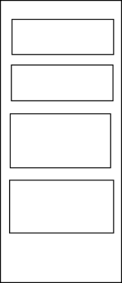

Gateway

Subnet

Database

Subnet

Shared

services

Subnet

10.20.10.0/24

Public web

service Subnet

10.20.30.0/24



Manufacturing

system

Subnet



Senesor

Subnet

110.30.20.0/24



Senesor

Subnet

2

10.30.21.0/24



Senesor

Subnet

310.30.22.0/24

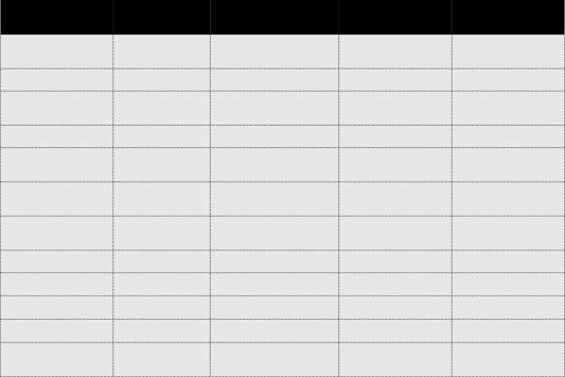

**Virtual**

**Network**



**Region**



**Virtual**

**network**

**address**

**space**



**Subnet**

**name**



**Subnet**



CoreServices



Kolkatta



10.20.0.0/16



Gateway

Subnet

10.20.0.0/27

Shared

Services

10.20.10.0/24

Subnet

Database

Subnet

10.20.20.0/24

Public

Web

10.20.30.0/24

Service

Subnet

Manufacturing



Manufacturing

Vnet



Karnataka



10.30.0.0/16



System

Subnet



10.30.10.0/24



SensorSubnet1

SensorSubnet2



10.30.20.0/24



SensorSubnet3



10.30.21.0/24

10.30.22.0/24



Research

Vnet



Mumbai



10.40.0.0/16



Research

System

10.40.0.0/24

Subnet